**LAB 3**

**OBJECTIVE**

To implement high pass and low pass filter.

**THEORY**

A low pass filter is used to pass low-frequency signals. The strength of the signal is reduced and frequencies which are passed is higher than the cut-off frequency. The amount of strength reduced for each frequency depends on the design of the filter. Smoothing is low pass operation in the frequency domain.

A high pass filter is used for passing high frequencies but the strength of the frequency is lower as compared to cut off frequency. Sharpening is a high pass operation in the frequency domain. As low pass filter, it also has standard forms such as Ideal highpass filter, Butterworth highpass filter, Gaussian high pass filter.

High-pass and low-pass filters are also used in digital image processing to perform image modifications, enhancements, noise reduction, etc. using designs done in either the spatial domain or the frequency domain. The unsharp masking, or sharpening, operation used in image editing software is a high-boost filter, a generalization of high-pass.

**CODE**

% Program 1: High pass and low pass filter

RGB=imread('image.jpg');

I=rgb2gray(RGB); % Convert the image to grayscale image

A=fft2(double(I)); % Compute the FFT of the grey image

A1=fftshift(A); % Frequency scaling

% Gaussian Filter Response Calculation

[M,N]=size(A); % Image size

R=10; % Filter size parameter

X=0:N-1;

Y=0:M-1;

[X,Y]=meshgrid(X,Y);

Cx=0.5*N;

Cy=0.5*M;

Lo=exp(-((X-Cx).^2+(Y-Cy).^2)./(2*R).^2);

Hi=1-Lo; % High pass filter=1-low pass filter

J=A1.*Lo;

J1=ifftshift(J);

B1=ifft2(J1);

K=A1.*Hi;

K1=ifftshift(K);

B2=ifft2(K1);

% Visualizing the results

figure(1)

imshow(I);colormap gray

title('Original Image','fontsize',14)

figure(2)

imshow(abs(A1),[-12 300000]),colormap gray

title('FFT of original image', 'fontsize',14)

figure(3)

imshow(abs(B1),[12 290]),colormap gray

title('Low pass filtered image','fontsize',14)

figure(4)

imshow(abs(B2),[12 290]),colormap gray

title('High pass filtered image','fontsize',14)

**OUTPUT**

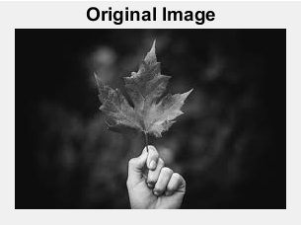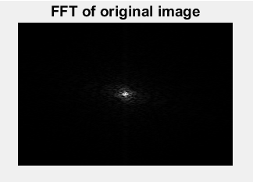

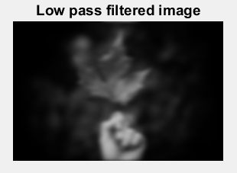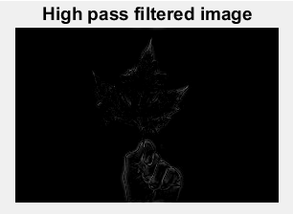

**CONCLUSION**

In this lab, I got familiar with high pass and low pass filter and applied them in a digital image.